**ELEC 204 Digital Design Lab Report**

Lab 1

Name: Mehmet Enes Erciyes

Lab Collaborator: Bulut Boru

Date: 10/13/2019

*Please delete the highlighted lines and write your own parts for the report.

**Reminder: Your lab grade is a weighted average of your performance before, during and after the lab: **Total lab grade = Preliminary work* (30%) + Lab interview and demo* (40%) + Lab report (30%)**

**\*\*\*Please make sure the lab report does not exceed 4 A4 pages.**

****Please make sure you indicate the name of your lab collaborator (if there is any) who you worked together to solve the lab questions. Do not change your lab collaborator throughout the semester.

1. **Introduction and objectives**

In Lab 1, we designed a 3-bit comparator module that takes two 3-bit unsigned binary numbers and shows which one is greater or whether they are equal or not.

1. **Methods**

### Inputs

For our comparator, we needed two inputs which were bus inputs composed by 3 bits. I named two inputs as ‘A’ and ‘B’.

* A : 3-bit unsigned binary number
  + A(2) was assigned to “P88” switch
  + A(1) was assigned to “P90” switch
  + A(0) was assigned to “P94” switch
* B: 3-bit unsigned binary number
  + B(2) was assigned to “P5” switch
  + B(1) was assigned to “P12” switch
  + B(0) was assigned to “P15” switch

These inputs were defined in main VHDL module and assigned to switches in main implementation constraints file.

### Outputs

We designed our comparator to give three possible outputs:

* A greater than B (AG)
* B greater than A (BG)
* A and B are equal (EQ)

These outputs are assigned to the Boolean algebra expressions that were derived in preliminary work by using K-Maps. Then, they were delegated to separate LED’s on the board.

* AG was assigned to “P6” left LED
* BG was assigned to “P16” right LED
* EQ was assigned to “P13” middle LED

### What VHDL Code Should Do?

VHDL Code must successfully define inputs and outputs and assign correct Boolean algebra expressions to output values that will show the comparison between inputs, A and B, in the main VHDL module. Then, it must assign inputs to correct switches and outputs to correct LED’s in the main implementation constraints file.

### How VHDL Code Works?

Main VHDL module first defines the module and inputs and outputs. Then, in the behavioral block, derived expressions are assigned to output values. The implementation constraints file, on the other hand, determines which switches and LEDs affect inputs and show outputs. Every time input switches change, boolean expressions are reevaluated with new A and B values and output LEDs are lit according to the value of AG, BG and EQ.

### Truth Table for AG, BG and EQ

* *EQ = (A1 ⊕ B1)’ (A2 ⊕ B2)’ (A2 ⊕ B2)'*
* *BG = B2A2’ + (A2⊕B2)’[A1’B1+(A1⊕B1)’(B0A0’)]*
* *AG = A2(B2’) + (A2⊕B2)’[A1B1’ + (A1⊕B1)’(A0B0’)]*

|  |  |  |  |  |  |  |  |  |
| --- | --- | --- | --- | --- | --- | --- | --- | --- |
| A(2) | A(1) | A(0) | B(2) | B(1) | B(0) | AG | BG | EQ |
| 0 | 0 | 0 | 0 | 0 | 0 | 0 | 0 | 1 |
| 0 | 0 | 0 | 0 | 0 | 1 | 0 | 1 | 0 |
| 0 | 0 | 0 | 0 | 1 | 0 | 0 | 1 | 0 |
| 0 | 0 | 0 | 0 | 1 | 1 | 0 | 1 | 0 |
| 0 | 0 | 0 | 1 | 0 | 0 | 0 | 1 | 0 |
| 0 | 0 | 0 | 1 | 0 | 1 | 0 | 1 | 0 |
| 0 | 0 | 0 | 1 | 1 | 0 | 0 | 1 | 0 |
| 0 | 0 | 0 | 1 | 1 | 1 | 0 | 1 | 0 |
| 0 | 0 | 1 | 0 | 0 | 0 | 1 | 0 | 0 |
| 0 | 0 | 1 | 0 | 0 | 1 | 0 | 0 | 1 |
| 0 | 0 | 1 | 0 | 1 | 0 | 0 | 1 | 0 |
| 0 | 0 | 1 | 0 | 1 | 1 | 0 | 1 | 0 |
| 0 | 0 | 1 | 1 | 0 | 0 | 0 | 1 | 0 |
| 0 | 0 | 1 | 1 | 0 | 1 | 0 | 1 | 0 |
| 0 | 0 | 1 | 1 | 1 | 0 | 0 | 1 | 0 |
| 0 | 0 | 1 | 1 | 1 | 1 | 0 | 1 | 0 |
| 0 | 1 | 0 | 0 | 0 | 0 | 1 | 0 | 0 |
| 0 | 1 | 0 | 0 | 0 | 1 | 1 | 0 | 0 |
| 0 | 1 | 0 | 0 | 1 | 0 | 0 | 0 | 1 |
| 0 | 1 | 0 | 0 | 1 | 1 | 0 | 1 | 0 |
| 0 | 1 | 0 | 1 | 0 | 0 | 0 | 1 | 0 |
| 0 | 1 | 0 | 1 | 0 | 1 | 0 | 1 | 0 |
| 0 | 1 | 0 | 1 | 1 | 0 | 0 | 1 | 0 |
| 0 | 1 | 0 | 1 | 1 | 1 | 0 | 1 | 0 |
| 0 | 1 | 1 | 0 | 0 | 0 | 1 | 0 | 0 |
| 0 | 1 | 1 | 0 | 0 | 1 | 1 | 0 | 0 |
| 0 | 1 | 1 | 0 | 1 | 0 | 1 | 0 | 0 |
| 0 | 1 | 1 | 0 | 1 | 1 | 0 | 0 | 1 |
| 0 | 1 | 1 | 1 | 0 | 0 | 0 | 1 | 0 |
| 0 | 1 | 1 | 1 | 0 | 1 | 0 | 1 | 0 |
| 0 | 1 | 1 | 1 | 1 | 0 | 0 | 1 | 0 |
| 0 | 1 | 1 | 1 | 1 | 1 | 0 | 1 | 0 |
| 1 | 0 | 0 | 0 | 0 | 0 | 1 | 0 | 0 |
| 1 | 0 | 0 | 0 | 0 | 1 | 1 | 0 | 0 |
| 1 | 0 | 0 | 0 | 1 | 0 | 1 | 0 | 0 |
| 1 | 0 | 0 | 0 | 1 | 1 | 1 | 0 | 0 |
| 1 | 0 | 0 | 1 | 0 | 0 | 0 | 0 | 1 |
| 1 | 0 | 0 | 1 | 0 | 1 | 0 | 1 | 0 |
| 1 | 0 | 0 | 1 | 1 | 0 | 0 | 1 | 0 |
| 1 | 0 | 0 | 1 | 1 | 1 | 0 | 1 | 0 |
| 1 | 0 | 1 | 0 | 0 | 0 | 1 | 0 | 0 |
| 1 | 0 | 1 | 0 | 0 | 1 | 1 | 0 | 0 |
| 1 | 0 | 1 | 0 | 1 | 0 | 1 | 0 | 0 |
| 1 | 0 | 1 | 0 | 1 | 1 | 1 | 0 | 0 |
| 1 | 0 | 1 | 1 | 0 | 0 | 1 | 0 | 0 |
| 1 | 0 | 1 | 1 | 0 | 1 | 0 | 0 | 1 |
| 1 | 0 | 1 | 1 | 1 | 0 | 0 | 1 | 0 |
| 1 | 0 | 1 | 1 | 1 | 1 | 0 | 1 | 0 |
| 1 | 1 | 0 | 0 | 0 | 0 | 1 | 0 | 0 |
| 1 | 1 | 0 | 0 | 0 | 1 | 1 | 0 | 0 |
| 1 | 1 | 0 | 0 | 1 | 0 | 1 | 0 | 0 |
| 1 | 1 | 0 | 0 | 1 | 1 | 1 | 0 | 0 |
| 1 | 1 | 0 | 1 | 0 | 0 | 1 | 0 | 0 |
| 1 | 1 | 0 | 1 | 0 | 1 | 1 | 0 | 0 |
| 1 | 1 | 0 | 1 | 1 | 0 | 0 | 0 | 1 |
| 1 | 1 | 0 | 1 | 1 | 1 | 0 | 1 | 0 |
| 1 | 1 | 1 | 0 | 0 | 0 | 1 | 0 | 0 |
| 1 | 1 | 1 | 0 | 0 | 1 | 1 | 0 | 0 |
| 1 | 1 | 1 | 0 | 1 | 0 | 1 | 0 | 0 |
| 1 | 1 | 1 | 0 | 1 | 1 | 1 | 0 | 0 |
| 1 | 1 | 1 | 1 | 0 | 0 | 1 | 0 | 0 |
| 1 | 1 | 1 | 1 | 0 | 1 | 1 | 0 | 0 |
| 1 | 1 | 1 | 1 | 1 | 0 | 1 | 0 | 0 |
| 1 | 1 | 1 | 1 | 1 | 1 | 0 | 0 | 1 |

1. **Problems encountered, errors and warnings resolved**

When writing my code, I encountered several syntax problems:

* When writing boolean expressions in main module, I accidentally deleted the last line “end Behavioral;”. I got the error “Parse error: Unexpected EOL.” Then I managed to realize the missing code and solved the problem.
* Also, when writing boolean expressions, I misplaced some parantheses and got syntax errors. Then, I organized my code better and used indentation and problem was solved.
* In the implementaion constraints file, I forgot semi colons at the ends. I could not see the situation for a while and checked the tutorial videos. There, I realized the problem and fixed it.

As for the problems after successful sythesizing, I misassigned the switches of A(2) and A(0) (one in another’s place). Then I corrected the implementation file and solved the problem.

1. **Conclusion**

In this lab, I learned how to build a 3-bit comparator from scratch by using boolean algebra and VHDL code. First, I created k-maps for 3 output values, AG,BG and EQ. Then, I used prime implicants and Boolean algebra identities to simplify the expressions. In the experiment part, I assigned this expressions to outputs and programmed an FPGA to compare two 3-bit numbers. While doing this, I learned to use ISE and Prometheus to write VHDL code, make the correct implementaion, synthesize it and download it to FPGA and run it. I had the chance to see how digital circuits (i.e computers) compare two numbers in the lowest level. I understood how boolean algebra is implemented on a digital circuit.

References

At the making of this lab project, I used the tutorial lab videos extensively for learning and debugging my errors.

**Appendix 1. Lab source code**

**main.vhd**

library IEEE;

use IEEE.STD_LOGIC_1164.ALL;

-- Uncomment the following library declaration if using

-- arithmetic functions with Signed or Unsigned values

--use IEEE.NUMERIC_STD.ALL;

-- Uncomment the following library declaration if instantiating

-- any Xilinx primitives in this code.

--library UNISIM;

--use UNISIM.VComponents.all;

entity main is

Port ( A : in STD_LOGIC_VECTor (2 downto 0);

B : in STD_LOGIC_VECTor (2 downto 0);

AG : out STD_LOGIC;

BG : out STD_LOGIC;

EQ : out STD_LOGIC);

end main;

architecture Behavioral of main is

begin

AG <= (

(A(2) and (not B(2))) or

(

(A(2) xnor B(2)) and

(

(A(1) and (not B(1))) or

(

(A(1) xnor B(1)) and (A(0) and (not B(0)))

)

)

)

);

BG <= (

(B(2) and (not A(2))) or

(

(A(2) xnor B(2)) and

(

((not A(1)) and B(1)) or

(

(A(1) xnor B(1)) and (B(0) and (not A(0)))

)

)

)

);

EQ <= ((A(0) xnor B(0)) and (A(1) xnor B(1)) and (A(2) xnor B(2)));

end Behavioral;

**main_implementation.ucf**

net A(0) loc = "P94";

net A(1) loc = "P90";

net A(2) loc = "P88";

net B(0) loc = "P15";

net B(1) loc = "P12";

net B(2) loc = "P5";

net AG loc = "P6";

net EQ loc = "P13";

net BG loc = "P16";

**Appendix 2. RTL schematics**

**EQ RTL SCHEMATIC**

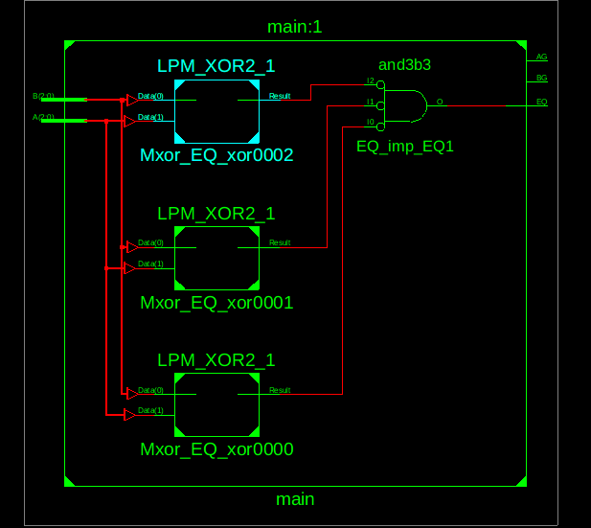

**AG RTL SCHEMATIC**

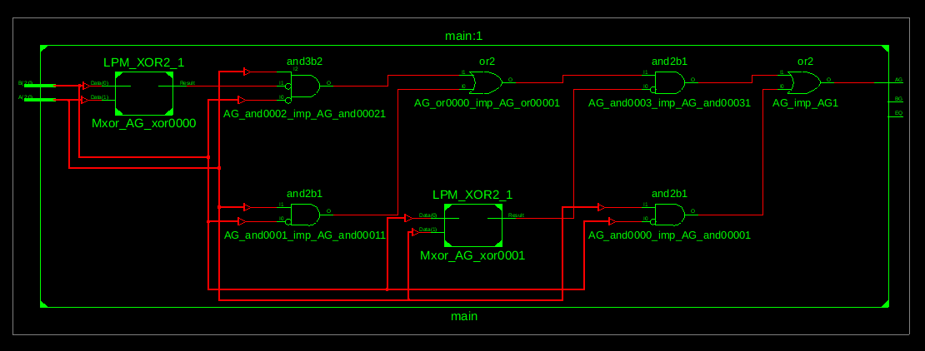

**BG RTL SCHEMATIC**

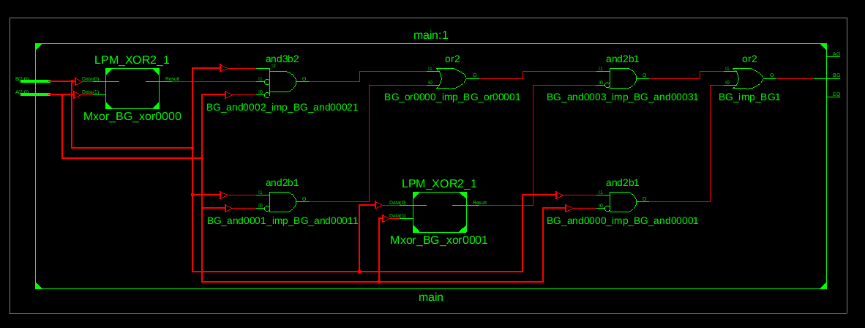

**Appendix 3. FPGA Board photos showing working code**

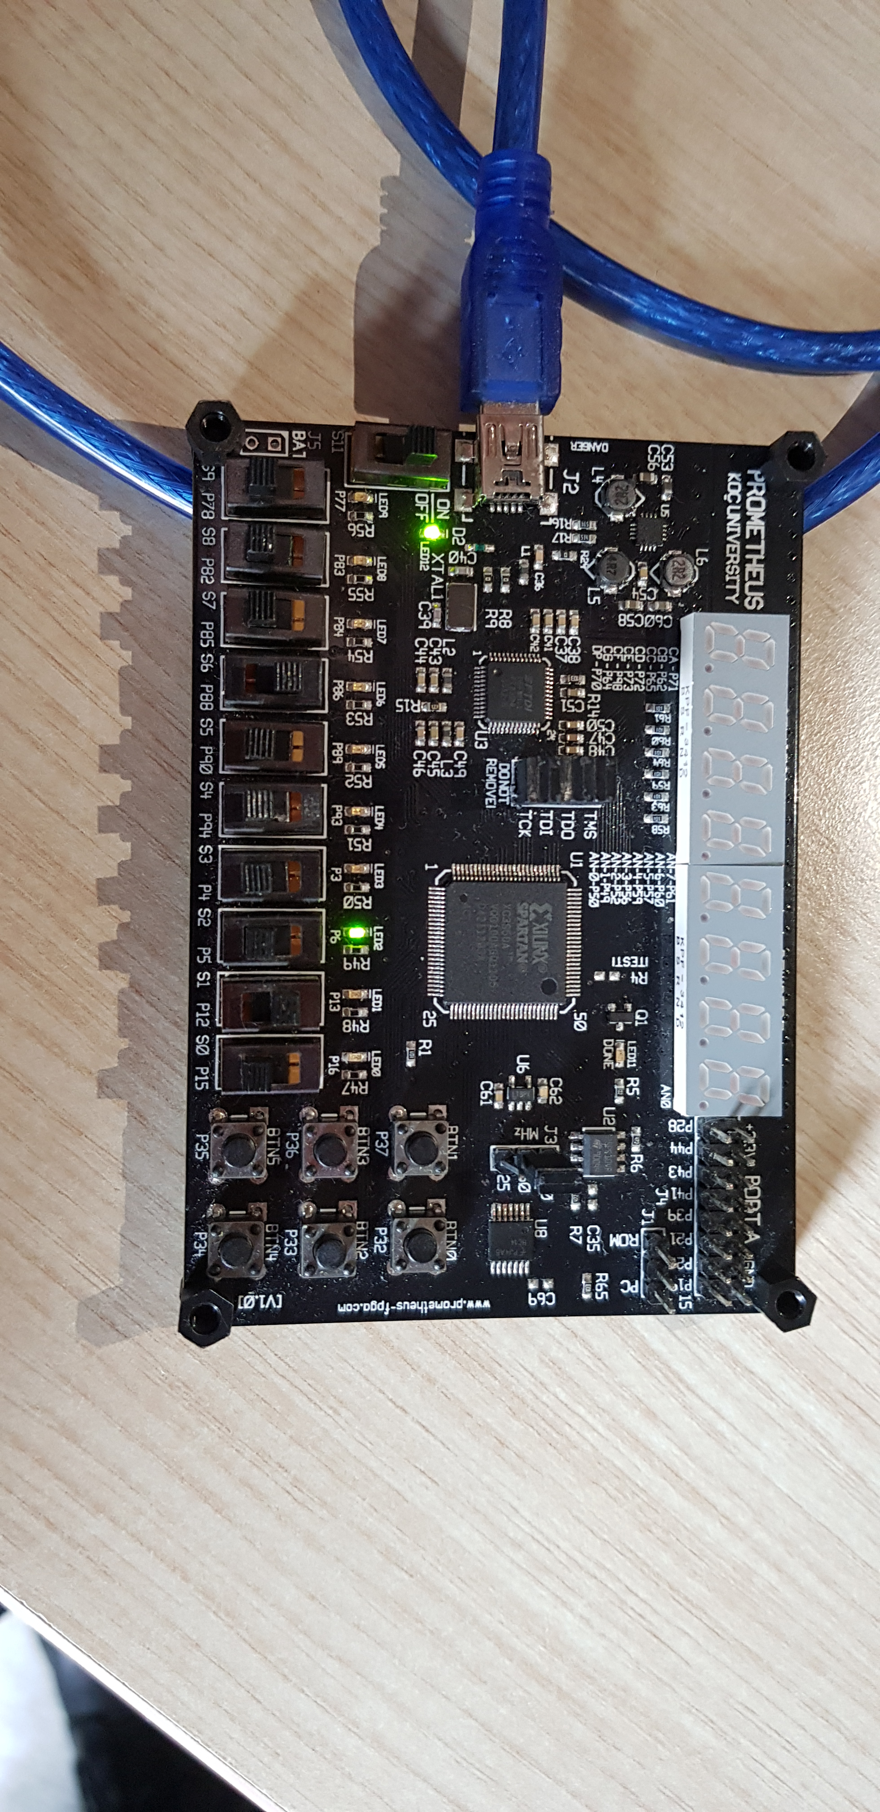

A=(100) , B=(010) , The LED that indicates AG is lit

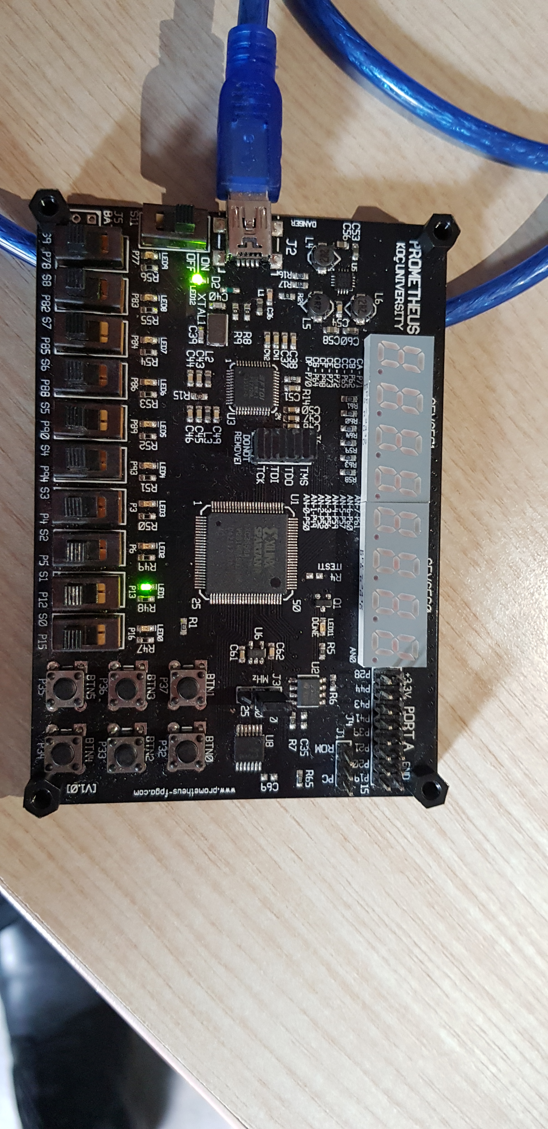

A=(000), B=(000), The led indicating EQ is lit

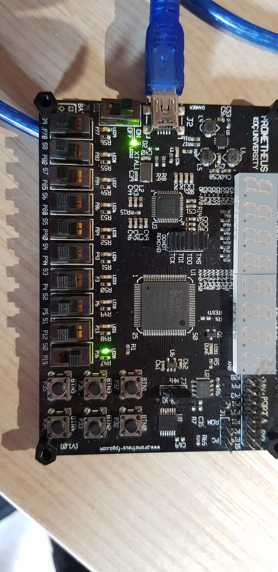

A=(000), B= (001), The led indicating BG is lit

**Appendix 4. Screenshots from Xilinx for the errors and other board issues**

For this lab, I was not aware that I needed to take the screenshots for errors. Therefore, I have not taken any. But, I have explained the errors I encountered and how I solved them in a previous part of this report.